### **Introduction**

### **Purpose**

The purpose of this System Requirement Specification document is describing the security system which is called Biometric identification based on Face. This system aims to provide a security system which holds a personal information keep in safe and decrease the rate of information theft against who want to steal your private information. This document includes detailed information about requirements of the project. Overall, this document is used for how users interact with the system and understand how the mechanism works at backend without any problems and explains how concerns of the stakeholders are met.

### **Scope of Project**

Most of the people use a private computer to do their jobs in the company and they may need to hide information in documents which relevant to work. Some information can be public and this files that are not important, if they are seized by someone else, but some files need a special protection system which is in the high-level secret status because people are wasting their time for hours on end and some hacker can steal their information from victim’s computer easily without any protection system and worst of all, people are unprepared for this situation. The application to be improved is Recognition of Human Face Patterns for Biometric Identification. This project involves developing a face detection system in order to verify the uniqueness of the human face by detecting the face pattern from the image.

### **Glossary:**

|  |  |
| --- | --- |
| **Term** | **Definition** |
| User | A person whose Face is to be recognized |
| Admin | A person who handles the application and enrolls a person image in the database |
| Database | Collection of all the information about the face and data of a person |
| Face Recognition | Control system for using human face for login to the system |
| Features | Result of information of the matrix which derives from grayscale image |
| Grayscale | A range of grey shades from white to black, as used in a monochrome display or printout. |

### **Overall Description**

### **System Environment**

This application is Face Recognition System as seems as Fig 1. Firstly, A person’s image should be provided using the camera. Then, camera transfers it to the Face Recognition System. Next, an image is preprocessed for features of face. After that, they are compared with an image in the system database and matched. The System Admin can do add and delete operations in the database, can set appropriate match rate of accepting user and handle whole application.

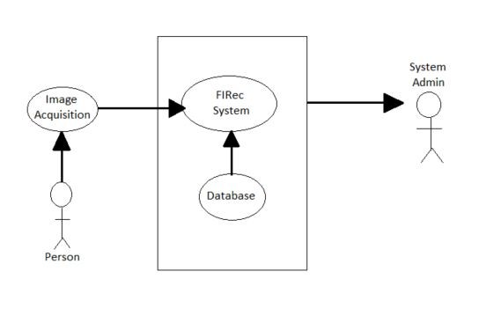

**Fig 1:** Process of Face Recognition

### **Development methodology**

While developing the project, we have decided to use Scrum which is an agile software development methodology. Scrum is part of the agile movement in a scrum, it has a sprint which includes work to do in the project. It takes a while almost between 2 and 4 weeks.

### **Functional Requirements Specification**

In this section, use cases are outlined for every single actor. System admin is the main actor and just one use case belongs to the user. Functional Requirements of Requirement Specification and this section are similar to each other.

### **User Interface Specification**

The framework holder is anticipated to be able to utilize button, pull-down menus, and comparative devices. A window with graphical client interface will be utilized. To begin with, of all we have chosen to store the highlights of face shape of the pictures of a face of people and utilize those highlights for acknowledgment. In case the input image's highlights coordinate up with the already put away highlights in the database, at that point a message will be shown illuminating an effective acknowledgment along with the subtle elements of the comparing individual.

### **Non-Functional Requirements**

In the Face Recognition system, the input is an image. The system will be implemented in Python. The user should not move during face detection in order to obtain high quality results. In addition, the environment should not be too bright and dark while detecting the face. Oracle database will be used for store the features which include a User’s face pattern and make a comparison between active employee’s features with features for finding the current employee is exist in the database. Operating system will execute the system.

### **Performance the System Requirements**

The system will accept or reject user in 4 seconds, after scanning.

### **Requirements Specifications**

### **External Interface Requirements:**

### **User Interfaces:**

The user interface will run on Windows.

### **Hardware Interfaces:**

The Face Recognition system require a camera. The camera requires necessary driver installed within the operating system.

### **Software Interfaces:**

There are no external software interface requirements.

### **Communication Interfaces:**

There are no external communications interface requirements

### **Functional Requirements**

**Use Case Diagrams:**

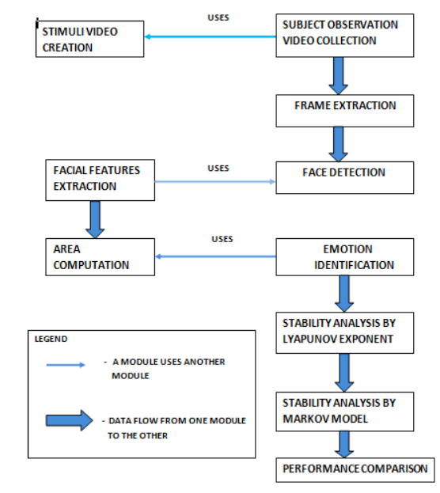

**Fig 2:** Diagram of Face Recognition

### **Detailed Non-Functional Requirements**

### **Security:**

The computer that runs the program will have its own security. Only the System Admin will log in to the system with his/her username and password. The person whose face are recognized will access to view the output.

**Maintainability:**

As a tool to obtain the ease of maintainability UML will be used in the development process.

**Portability:**

To ensure portability, the application will be developed in Python language and OpenCV Library.

**System Evolution**

The Face Recognition application are developed in Python. We are using Oracle as a database for storing features of employees. In the future, we can robust the algorithm to provide more accurate and consistent match-making recognition system. Also, we will reduce face recognition time under the 4 sec. Face Recognition System is available on the laptop which has an internal camera. Also, we are thinking to use Face Recognition System at bank ATMs and immigration system terminals for avoiding information theft and reducing crime rate for public safety.

**Face Recognition Process**

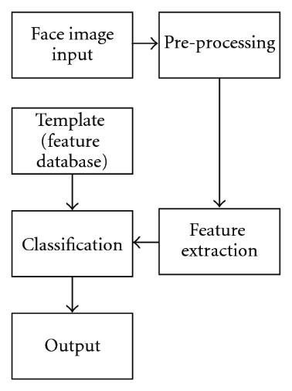

**Fig 3:** Flow Process of Face Recognition

**System Requirements**

Camera’s visual must run smoothly without any error and delay more than 4sec to get the image of the user. This requirement is depended on many aspects of the user pc. Minimum requirements for running Face Recognition System are:

|  |  |
| --- | --- |
| **Hardware and Software** | **Type** |
| **Processor** | Intel Core Processor or better performance |
| **Primary Memory** | 1 GB or more |
| **Secondary Memory** | 3 GB or more |
| **Graphics** | 800 MB or more |
| **Printer** | Not Required |
| **Operating System** | Windows and Linux Operating System |

**Table:** Hardware and Software Requirements

**4. References**

* <https://www.slideshare.net/gsantosh031/face-recognition-ppt>
* [http://www.researchpublish.com/download.php?file=Scope%20of%20Face%20Recognition%20Techniques-1815.pdf&act=book](http://www.researchpublish.com/download.php?file=Scope of Face Recognition Techniques-1815.pdf&act=book)
* [http://www.cs.uwc.ac.za/~dwarren/Dmitri%20Warren%20De%20Klerk%20-%202653786%20-%20Thesis.pdf](http://www.cs.uwc.ac.za/~dwarren/Dmitri Warren De Klerk - 2653786 - Thesis.pdf)
* [http://hanzratech.in](http://hanzratech.in/)
* <http://opencv-pythontutorials.readthedocs.io/en/latest/pytutorials/pyobjdetect/py_ facedetection/py_face_detectio n.html>
* <https://www.superdatascience.com/opencv-face-recognition/>
* <http://vismod.media.mit.edu/tech-reports/TR-516/node2.html>
* <https://link.springer.com/chapter/10.1007/978-3-540-30548-4_41>
* https://www.techopedia.com/definition/32071/facial-recognition